User requirement specifications

Individual assignment – Balan Mihai

Contents

Third iteration of project 3

Non-functional Requirements 4

**Remote Access: NFR-01** 4

**Performance: NFR-02** 4

**Expandability: NFR-03** 5

**Security: NFR-04** 5

**Accessibility and Usability: NFR-05** 5

Use Cases 5

**General** 5

**Administrator** 6

**Employees** 7

**Guests** 9

# Final iteration of project

|  |  |  |  |  |
| --- | --- | --- | --- | --- |
|  | Must have | Should have | Could have | Will not have |
| Administrator | 1. Log in: G-01, FR-01 2. Add employee:AD-01, FR-02 3. Remove employees:AD-02, FR-03 4. View all data of registered space objects in desktop:G-02, FR-05 5. View all data of registered space objects in web:G-03, FR-06 6. View details of objects in web: G-04, FR-07 7. Search for specific objects: G-05, FR-11 8. Change object view in desktop: G-06, FR-08 9. Edit own profile in website: G-07, FR-09 10. View map of objects: G-08, FR-18 11. Recover password: G-09, FR-19 12. View users statistics: AD-03, FR-12 13. Edit data of registered users: AD-04, FR-10 |  | 1. Posting announcements | 1. Live simulation of time and objects movement |
| Employee | 1. Log in: G-01, FR-01 2. View all data of registered space objects in desktop:G-02, FR-05 3. View all data of registered space objects in web:G-03, FR-06 4. View details of objects in web: G-04, FR-07 5. Search for specific objects: G-05, FR-11 6. Change object view in desktop: G-06, FR-08 7. Edit own profile in website: G-07, FR-09 8. View map of objects: G-08, FR-18 9. Recover password: G-09, FR-19 10. Add space object: EM-01, FR-13 11. Remove space objects: EM-02, FR-14 12. Edit existing objects: EM-03, FR-15 |  | 1. Calculate communication path: EM-04, FR-20 | 1. View statistics from other employees |
| Guest | 1. Log in: G-01, FR-01  2. View all data of registered space objects in desktop:G-02, FR-05  3. View all data of registered space objects in web:G-03, FR-06  4. View details of objects in web: G-04, FR-07   1. Search for specific objects: G-05, FR-11 2. Change object view in desktop: G-06, FR-08 3. Edit own profile in website: G-07, FR-09 4. View map of objects: G-08, FR-18 5. Recover password: G-09, FR-19 6. Create an account: GU-01, FR-16 7. Delete personal account: GU-02, FR-17 |  |  | * Access to communication or other complex features |

# Non-functional Requirements

*All of the functional requirements are of “Must Have” priority.

## **Remote Access: NFR-01**

* The application should allow employees of Astra Dynamics and regular people to access the system remotely, using a secure login.
* The web site should have a mobile-friendly interface for remote access.

## **Performance: NFR-02**

* The application should be able to handle a large amount of space objects
* The application should respond quickly to user inputs

## **Expandability: NFR-03**

* The application should be designed to allow for future expansion and development.
* The system should have modular architecture and well-documented code.
* The system should be designed to integrate with other software or services in the future.

## **Security: NFR-04**

* The application should be secure and protect sensitive data.
* The system should have user authentication and authorization controls.
* The system should encrypt data in transit and at rest.

## **Accessibility and Usability: NFR-05**

* The application should be easy to use and accessible to all users.
* The system should have clear and intuitive user interfaces.

# Use Cases

## **General**

**Use case: G-01**

Functional requirement: FR-01

Actor: Any user

Description: User uses his credentials to log into the system

Main success scenario:

1.Actor inputs name and password

2.Actor confirms

3.Credentials validated, actor is logged in.

4.System displays the main page

Extensions:

3a. Credentials did not match

.1: System displays message saying credentials did not match

.2: End of use case

**Use case: G-02**

Functional requirement: FR-05

Actor: Any user

Description: User views data of a space object in desktop app

Pre-condition: User is logged in

Main success scenario:

1. Actor selects an object from the list
2. System displays the information in the user interface

**Use case: G-03**

Functional requirement: FR-06

Actor: Any user

Description: User views data of a space object in website

Pre-condition: User is logged in

Main success scenario:

1. Actor clicks the tab Satellites/Stations/Debris
2. System displays the Satellites/Stations/Debris page
3. Information is visible in the website

**Use case: G-04**

Functional requirement: FR-07

Actor: Any user

Description: User views details of a selected object in web

Pre-condition: User is logged in

Main success scenario:

1. Actor clicks the tab Satellites/Stations/Debris
2. System displays the Satellites/Stations/Debris page
3. For individual object, actor clicks on the “Details” link
4. System displays the details page

Extensions:

2a. There were no objects available

.1: Details page is inaccessible

.2: End of use case

**Use case: G-05**

Functional requirement: FR-11

Actor: Any user

Description: User searches for a object in desktop

Pre-condition: User is logged in

Main success scenario:

1. Actor types in the search bar what he is looking for
2. List contains all matches, if any

**Use case: G-06**

Functional requirement: FR-05

Actor: Any user

Description: User changes the view of the object in desktop

Pre-condition: User is logged in

Main success scenario:

1. Actor selects an object
2. Actor selects between the “Model View”, “Blueprint View” and “Map View” buttons.
3. Picture is changed.

Extensions:

2a. No object was selected

.1: The default “Not Available” picture is visible

.2: End of use case

**Use case: G-07**

Functional requirement: FR-09

Actor: Any user

Description: User edits his profile in the website

Pre-condition: User is logged in

Main success scenario:

1. Actor clicks the profile button
2. System displays the profile page
3. Actor modifies his details
4. Actor clicks the “Save Changes” button
5. System displays the index page
6. Changes are reflected in the profile page

Extensions:

3a. The new details were invalid

.1: System displays an “Invalid Data” message

.2: Changes are not made

.3: End of use case

**Use case: G-08**

Functional requirement: FR-18

Actor: Any user

Description: User views the map of objects in orbit

Pre-condition: User is logged in

Main success scenario:

1. Actor clicks on the “Map” tab
2. System displays the math
3. The map is centered on the first object added, chronologically

**Use case: G-09**

Functional requirement: FR-19

Actor: Any user

Description: User recovers his forgotten password

Pre-condition: None

Main success scenario:

1. Actor clicks the “Forgot Password” tab
2. System displays the “Forgot Password” interface
3. Actor inputs his email
4. Actor clicks “Send Recovery Email”
5. Email will arrive with a new password in actor’s inbox

Extensions:

3a. Email was in incorrect format

.1: System displays a “Email address is invalid” message

.2: End of use case

3b. Email was in correct format, but not registered

.1: System displays a “No account registered with this email” message

.2: End of use case

## **Administrator**

**Use case: AD-01**

Functional requirement: FR-02

Actor: Administrator

Description: User adds a new employee, by filling in all data

Pre-conditions: Logged in as administrator

Main success scenario:

1. Actor clicks the “Add User” button
2. System displays the user adding page
3. Actor enters the info of the new employee

4. Actor clicks the ‘Add’ button

5. System displays a confirmation

Extensions:

3a. Data entered was invalid

.1: System displays error message saying data is invalid

.2: End of use case

3b. Email already existed

.1: System displays error message saying the email was already in use

.2: End of use case

**Use case: AD-02**

Functional requirement: FR-03

Actor: Administrator

Description: User removes a selected employee from the system

Pre-conditions: Logged in as administrator

Main success scenario:

1. Actor clicks the “Edit Users” tab
2. System displays the Edit Users interface
3. Actor selects a user
4. Actor clicks “Remove” button
5. System displays a confirmation

Extensions:

3a. Database did not respond

.1 System displays a message saying a connection error has occurred

.2 End of use case

**Use case: AD-03**

Functional requirement: FR-12

Actor: Administrator

Description: User views statistics of users

Pre-conditions: Logged in as administrator

Main success scenario:

1. Statistics are visible in the user interface, under the category “Users”

**Use case: AD-04**

Functional requirement: FR-10

Actor: Administrator

Description: User edits the data of another registered user

Pre-conditions: Logged in as administrator

Main success scenario:

1. Actor clicks the “Edit users” button
2. System displays the “Edit Users” interface
3. Actor selects a user
4. Actor modifies the user data
5. Actor inputs the user’s password
6. Actor clicks the “Save changes” button
7. System displays confirmation

Extensions:

5a. New data was invalid

.1: System displays an “Invalid Data” error message

.2: Changes are not saved

.3: End of use case

5b. Input password is incorrect

.1: System displays an “Invalid Password” error message

.2: Changes are not saved

.3: End of use case

## **Employee**

**Use case: EM-01**

Functional requirement: FR-13

Actor: Employee

Description: User adds a new space object

Pre-condition: Logged in as Employee

Main success scenario:

1. Actor clicks the Add Satellite/Add Station/Add Debris button
2. System displays the user interface for adding
3. Actor fills in all necessary fields
4. Actor clicks the “Add” button
5. System displays a confirmation of success

Extensions:

3a. Submitted data was invalid

.1: System displays an “Invalid data” error message

.2: End of use case.

**Use case: EM-02**

Functional requirement: FR-14

Actor: Employee

Description: User removes a selected object

Pre-condition: Logged in as Employee

Main success scenario:

1. Actor clicks the tab Edit Objects
2. System displays the “Edit Objects” interface
3. Actor selects an object
4. Actor clicks the “Remove” button
5. System displays a confirmation message

Extensions:

3a. No object was selected

.1: System displays a “No object selected” error message

.2: End of use case

**Use case: EM-03**

Functional requirement: FR-15

Actor: Employee

Description: User edits a selected object

Pre-condition: Logged in as Employee

Main success scenario:

1. Actor clicks the tab Edit Objects
2. System displays the Edit Objects interface
3. Actor selects an object
4. Actor edits the available fields of the object
5. Actor clicks the “Save changes” button
6. System displays a confirmation message

Extensions:

4a. New data in incorrect format

.1: System displays an “Invalid Data” error message

.2: Changes are not saved

.3: End of use case

**Use case: EM-04**

Functional requirement: FR-20

Actor: Employee

Description: User calculates the minimum path from a communication satellite from another

Pre-condition: Logged in as Employee

Main success scenario:

1. Actor clicks “Communications” button
2. System displays the “Communications” interface
3. Actor selects the source
4. Actor selects the destination
5. Actor clicks “ Calculate” button
6. System displays a list of Satellites the message has to pass through

Extensions:

5a. A path could not be found

.1: System displays the message “No path found”

.2: End of use case

## **Guest**

**Use case: GU-01**

Functional requirement: FR-16

Actor: Guest

Description: User creates a guest account

Pre-conditions: None

Main success scenario:

1. Actor clicks the “Get Started”/”Register”
2. System displays the registering interface
3. Actor fills in his details
4. Actor clicks the “Create Account” button.
5. System displays a confirmation
6. System displays the Login Page

Extensions:

3a. Input details were missing or in incorrect

.1: System displays specific error messages for every wrongfully completed field

.2: Account is not created

.3: End of use case

**Use case: GU-02**

Functional requirement: FR-17

Actor: Guest

Description: User deletes his personal account

Pre-conditions: None

Main success scenario:

1. Actor goes to the profile page
2. System displays the profile page
3. Actor clicks the “Delete account” button
4. Actor confirms his action
5. Account is deleted, actor is logged out

Extensions:

3a. Actor does not confirm his action

.1: End of use case

**User interfaces:**

* Guest desktop:

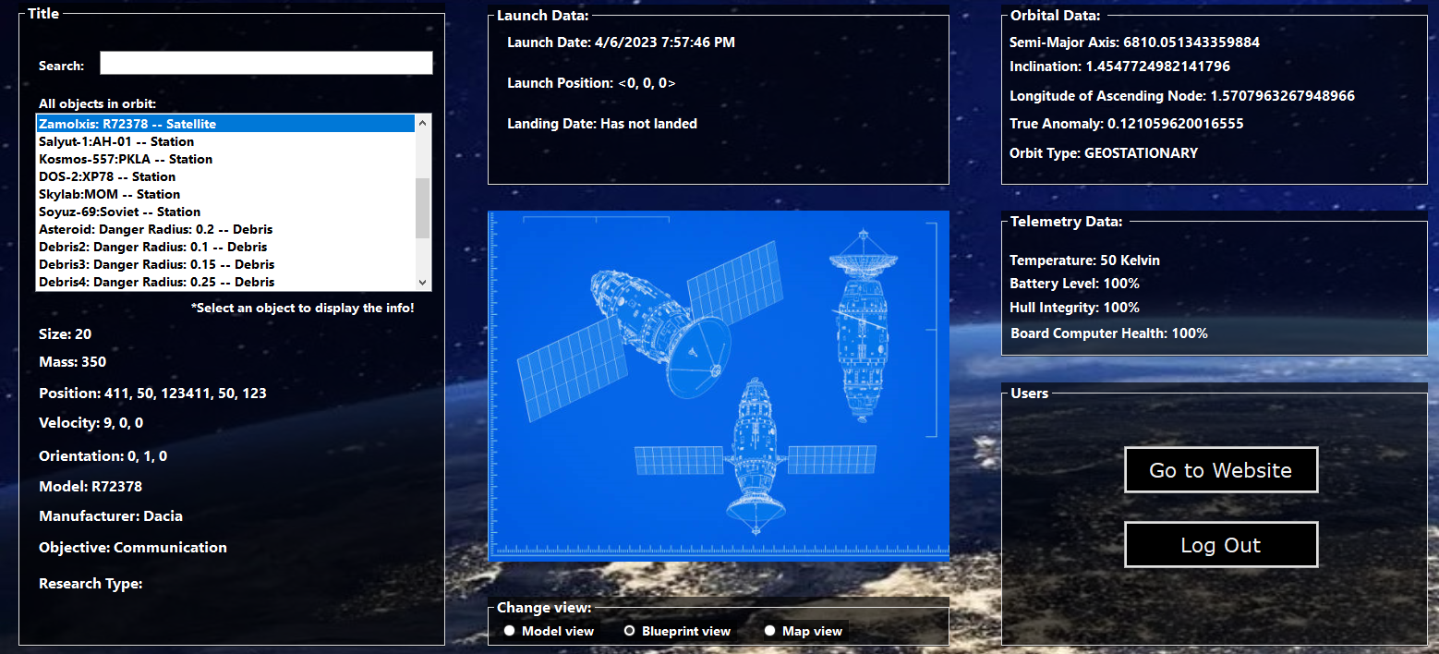

* Employee desktop:

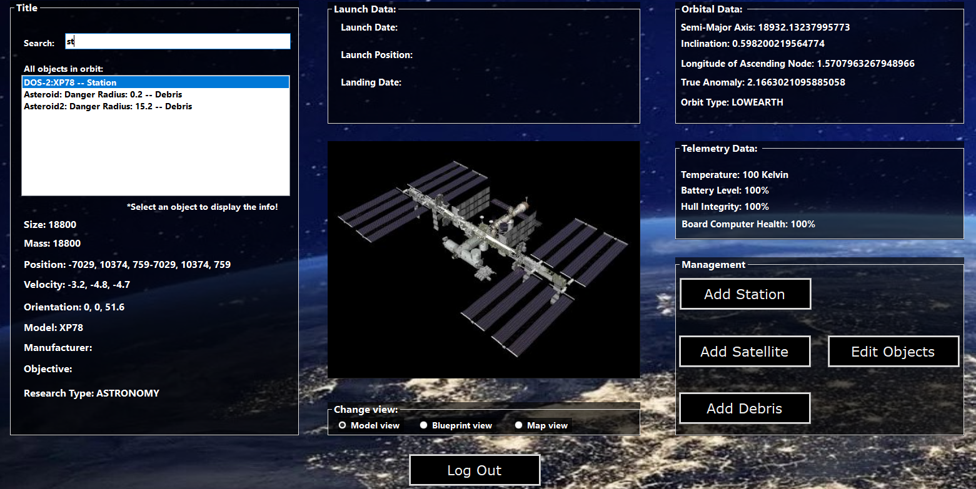

* Add Satellite:

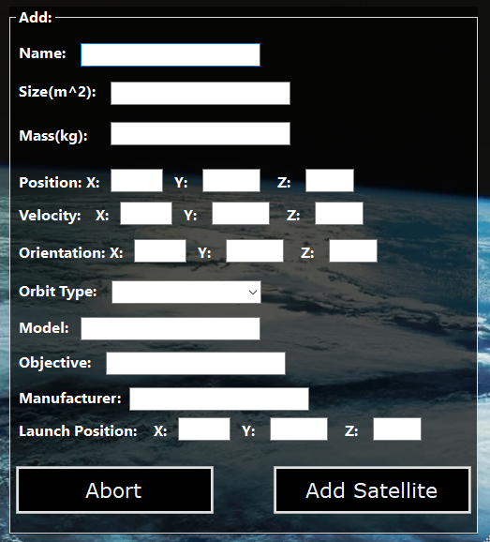

* Add Station:

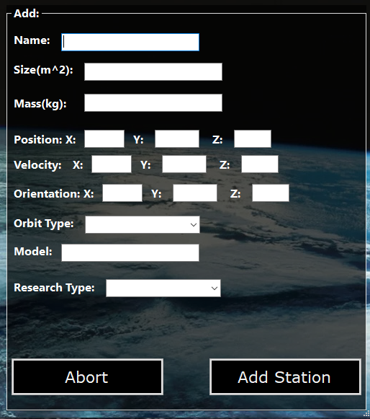

* Add Debris:

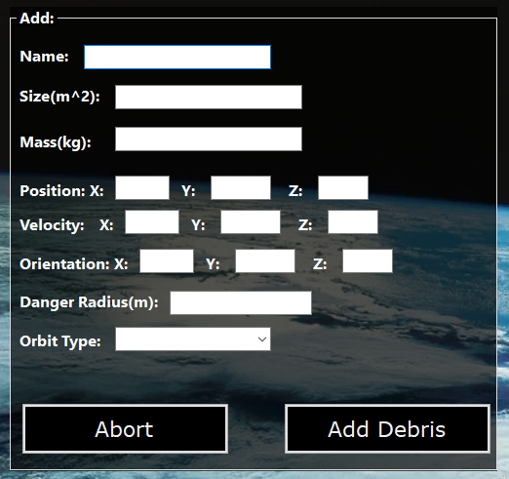

* Edit object:

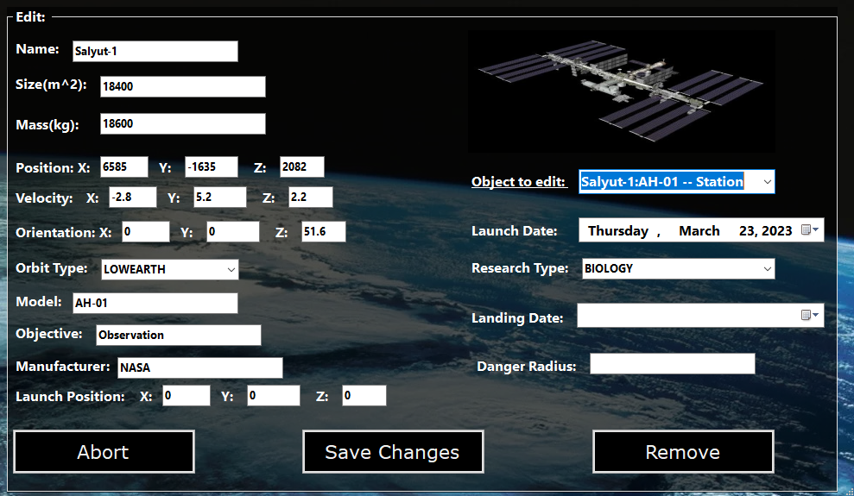

* Admin desktop:

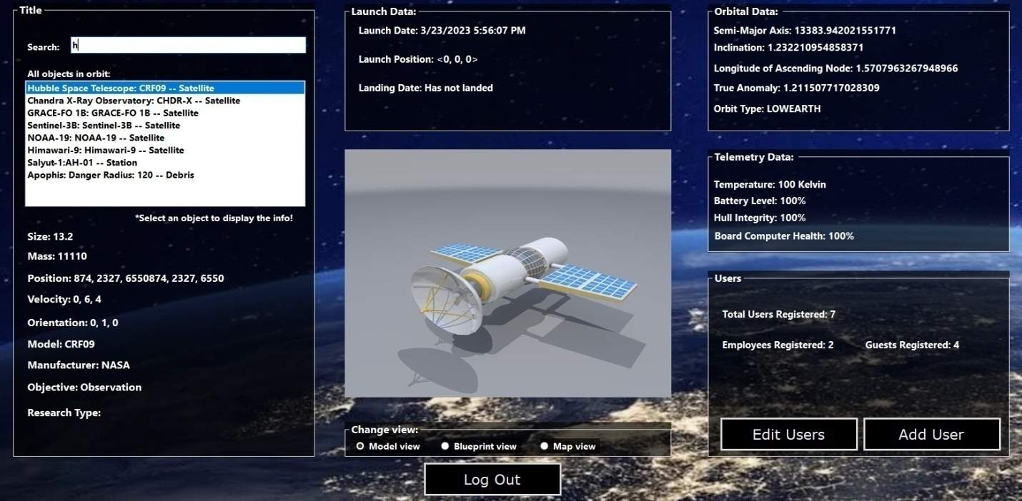

* Add user:

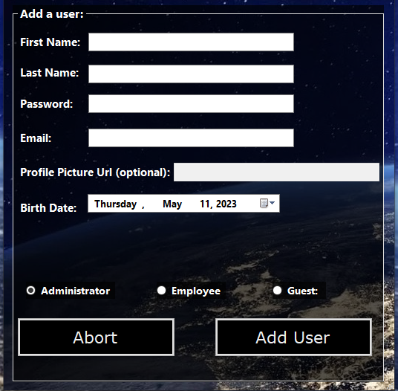

* Edit user:

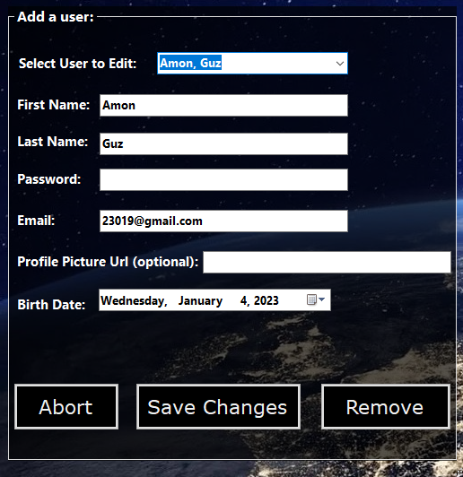

* Employee Communications calculator:

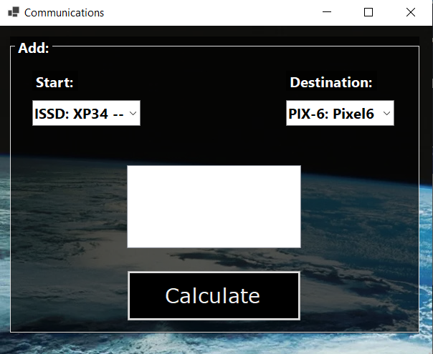

* Web landing page navbar(logged in):



* Web landing page:

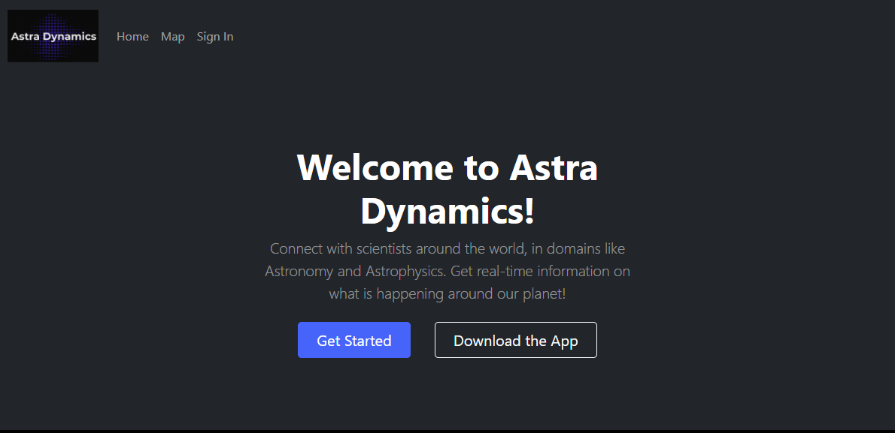

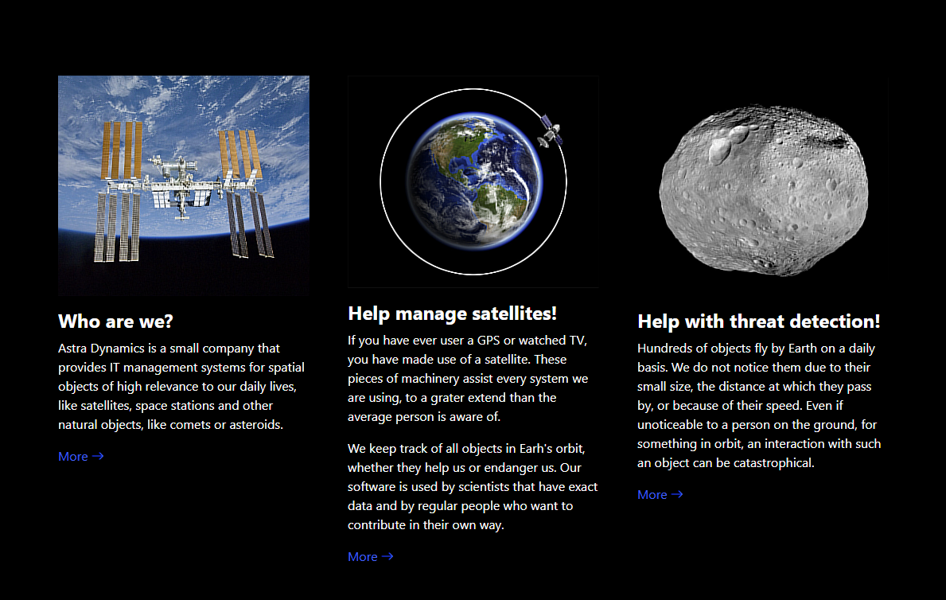

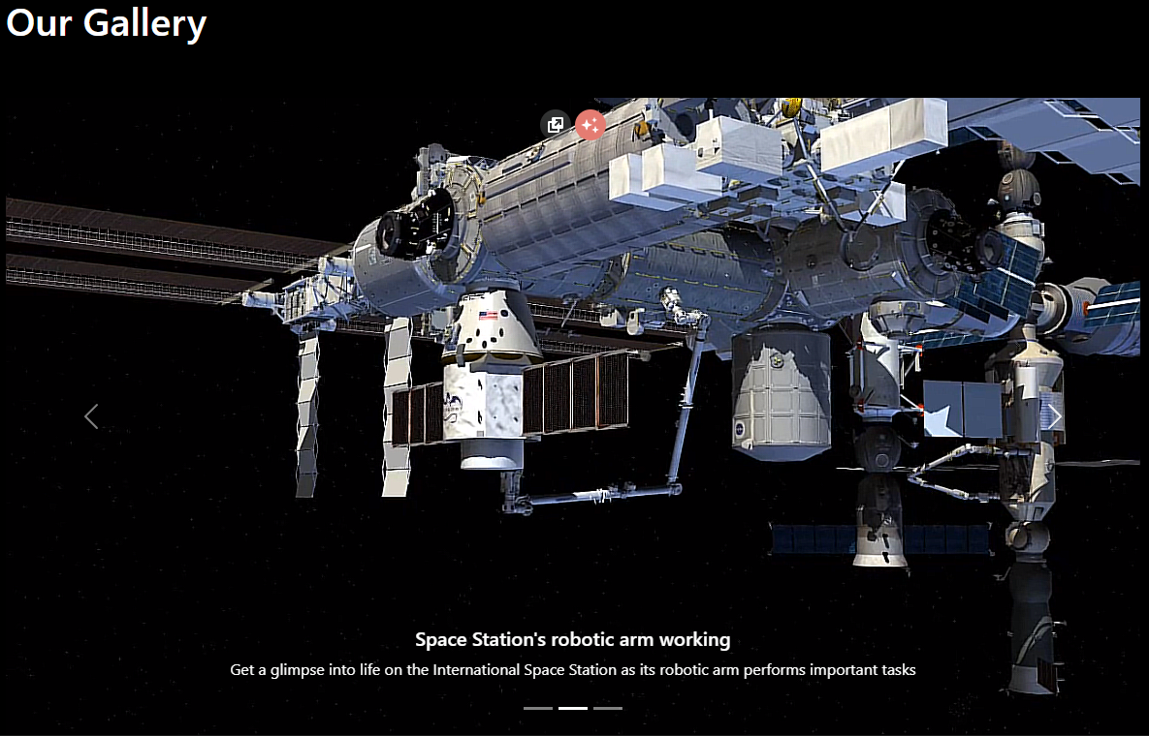

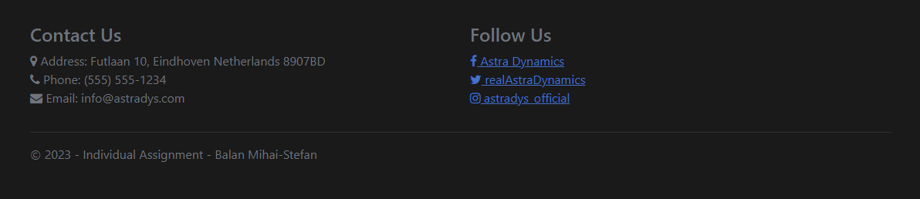

* Create account:

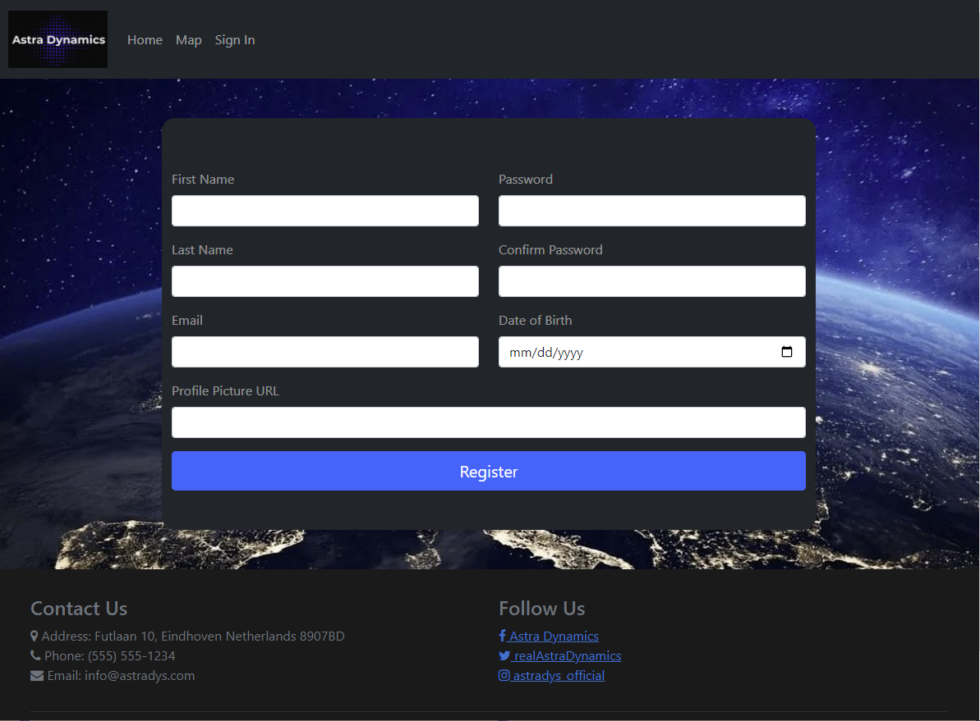

* Log In:

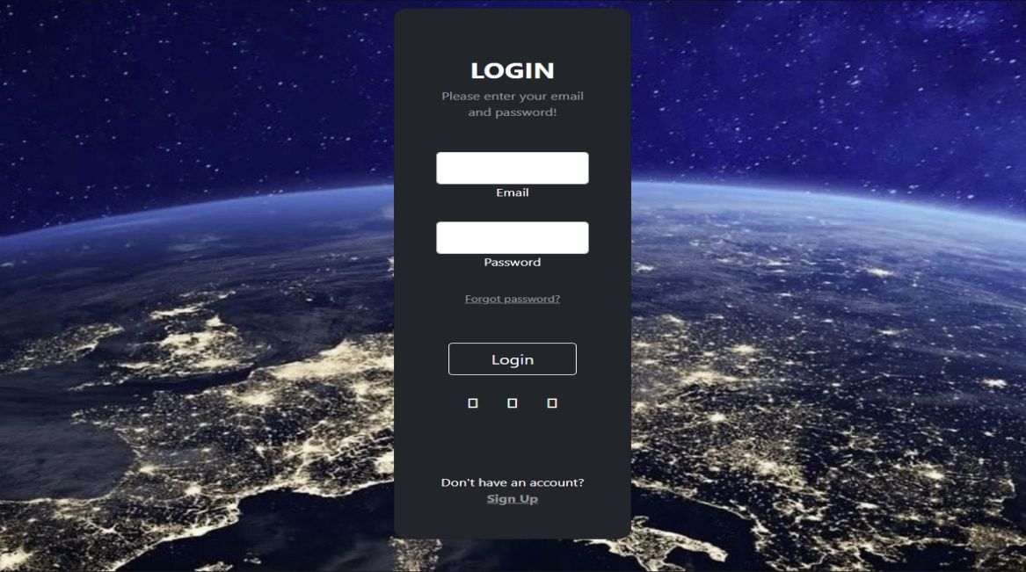

* Profile:

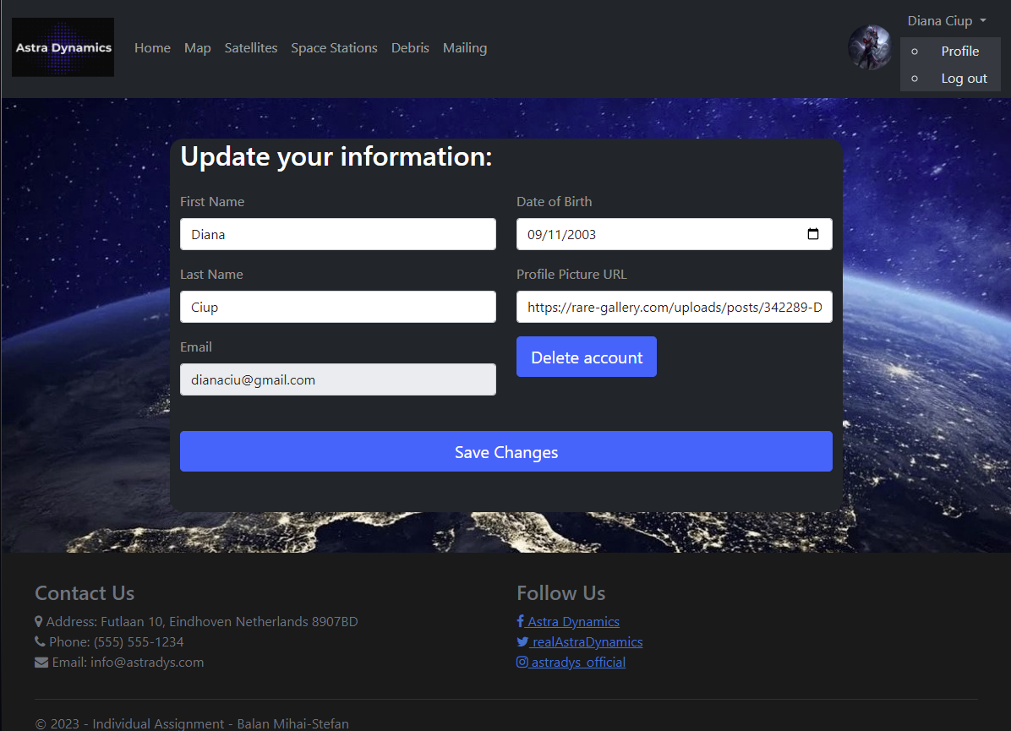

* Satellites:

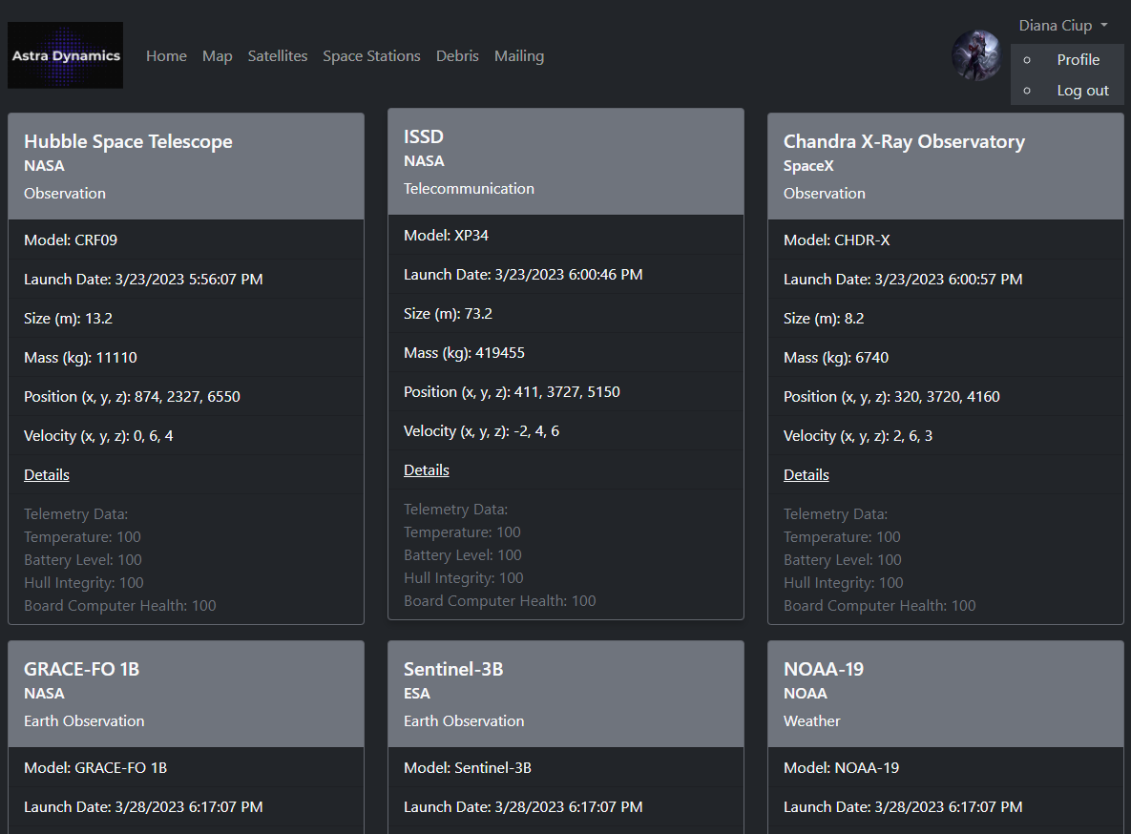

* Stations:

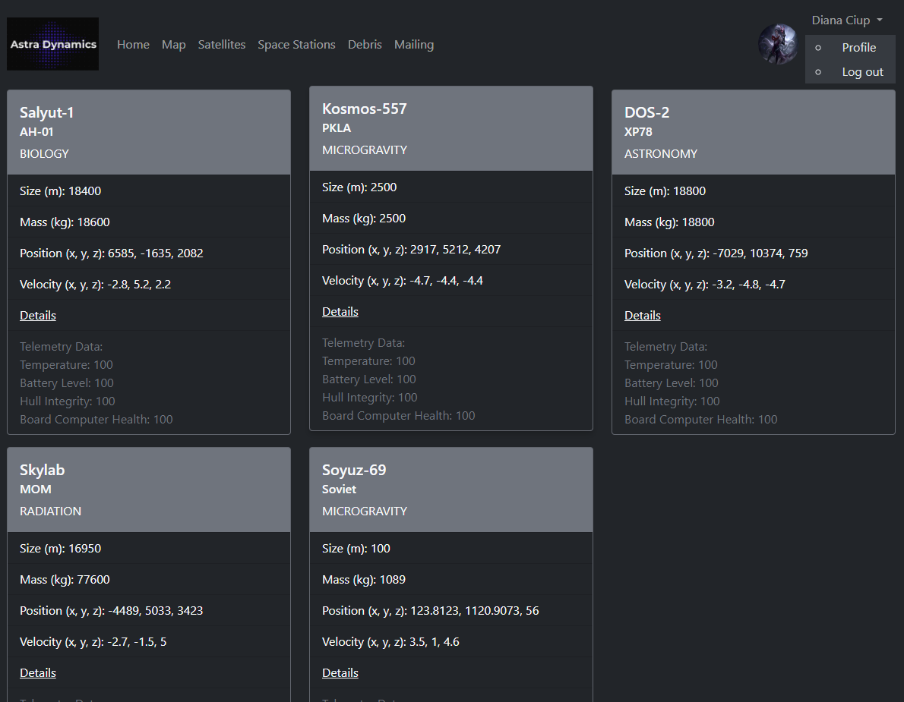

* Debris:

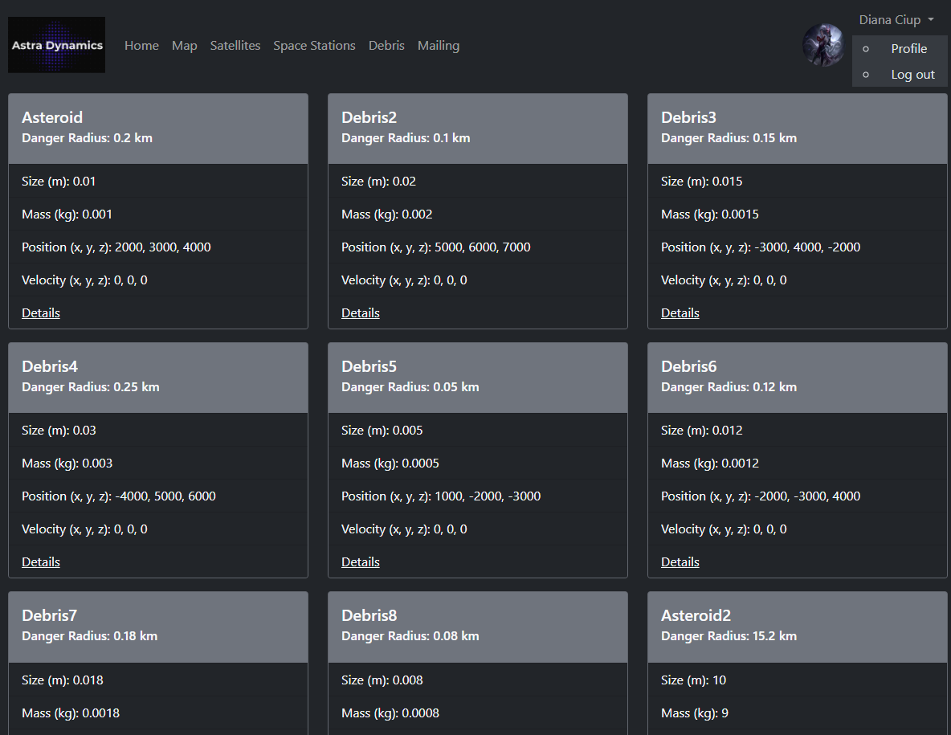

* Details:

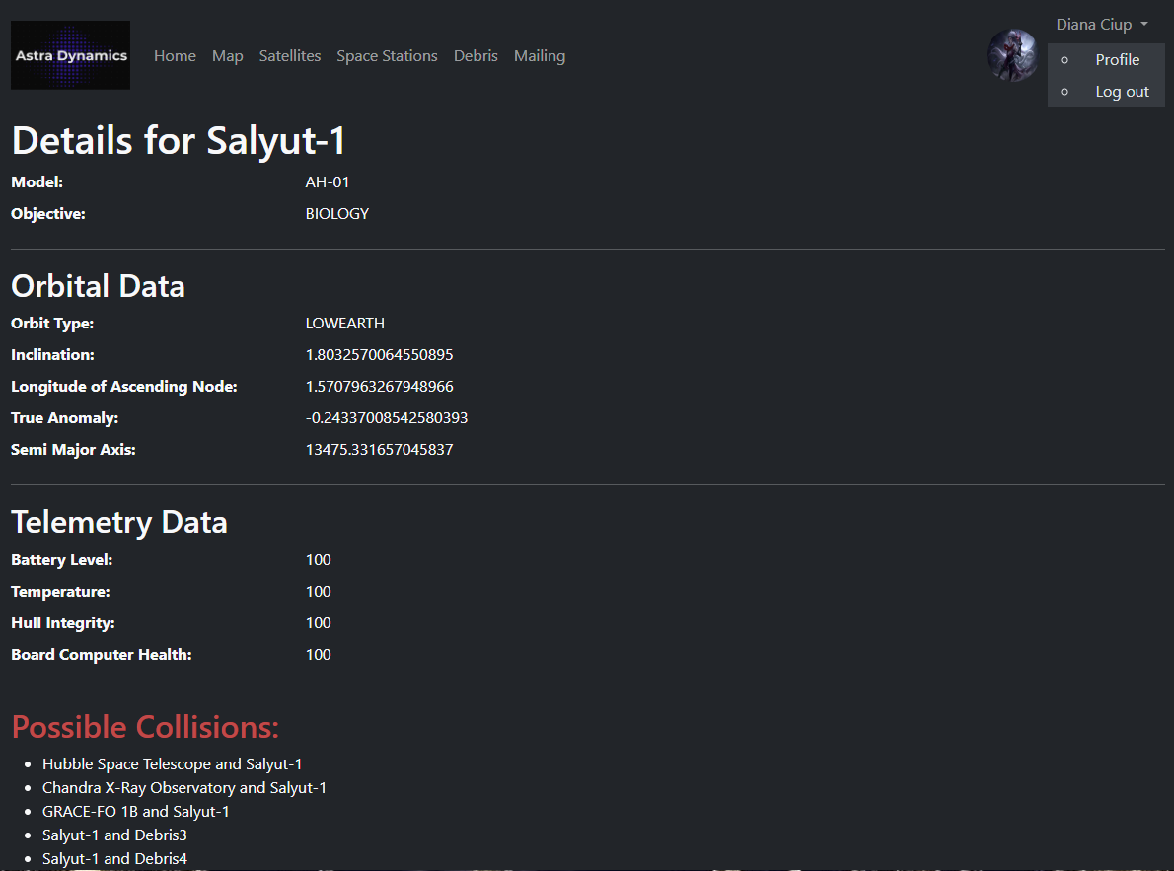

* Map:

